**WEEK – 3**

**1#** Type the passage below as it is. Use font size 12.

1. Save the document as maths.docx

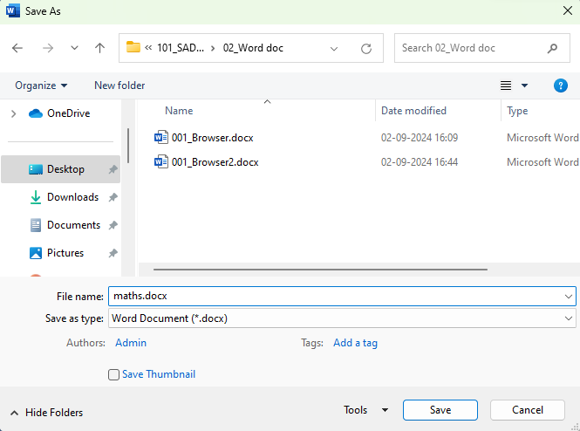

1. Change the case of the main heading to Title Case, Font size 16, double underline & Centre it.

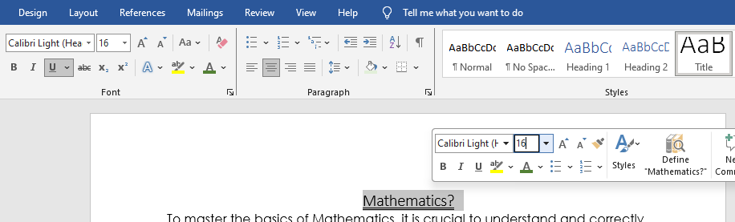

1. Put a border right around the passage and not the page.

Step 1: Go to **Home** tab

Step 2: Select the passages that you want to put a border around.

Step 3: In the Paragraph group, click on the drop-down button of the Borders icon 

Step 4: Select “Outside Borders”

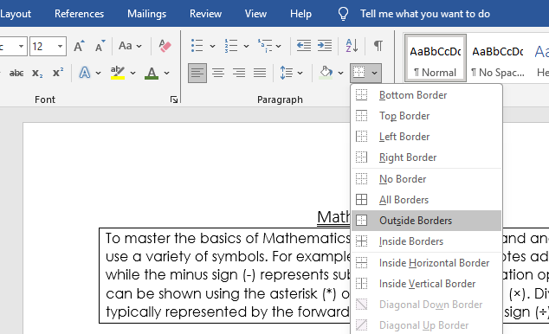

1. Justify all the paragraphs excluding the main heading

Step 1: Go to Home tab

Step 2: Select the passage you want to justify. In the paragraph group, click on the justify icon.

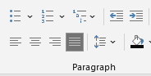

1. Change the font type of paragraph 2 to Bookman Old Style, font size 14.

Step 1: Select the second passage.

Step 2: Change the font type and font size using the menu that is displayed after you select the passage.

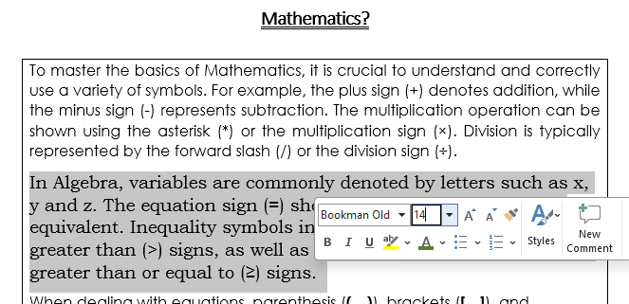

1. Divide the passage into 2 columns with a line between.

Step 1: Go to **Layout Tab**.

Step 2: Click on the “Columns” button.

Step 3: Select the “Two” option.

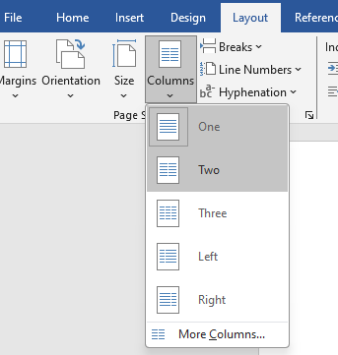

1. Drop cap all the paragraphs in your document excluding the headings.

Step 1: Go to the **Insert** Tab

Step 2: Click on **Drop cap** and select the “Dropped” option.

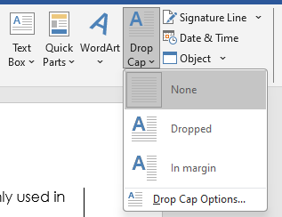

1. Change the line spacing of the entire document to 1.5 lines.

Step – 1: Select the entire text.

Step – 2: Go to line spacing in Paragraph section and select 1.5

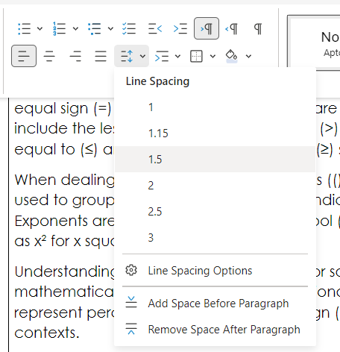

**i)**  Save the word file as math2.

**Step – 1:** Click on ‘Save As’

**Step – 2:** Name it math2.

**j)** Upload both in your GitHub account using add, commit, push etc command of Git.

# **Uploading to GitHub using commands:**

1. Download Git from: <https://git-scm.com/downloads>
2. Run the .exe file, follow through initialization process.
3. Open Git Bash
4. Locate your file, copy the address of the folder, and type “cd ~<Address of folder>”
5. Once inside the folder, run this command: git init
6. Run this command next:  
   git remote add origin [https://github.com/<your-username>/<Repositoryname>.git](https://github.com/%3cyour-username%3e/%3cRepositoryname%3e.git)
7. Run this command next:   
   git add math2.docx
8. Next, commit changes by executing this:  
   git commit -m "Initial commit - added required file"
9. Now enter the email and password of your account in the below lines and execute:  
   git config --global user.email [you@example.com](mailto:you@example.com)git config --global user.name "Your Name"
10. git config --global user.email <email>  
    git config --global user.name “<username>”

***FINAL DOCUMENT***

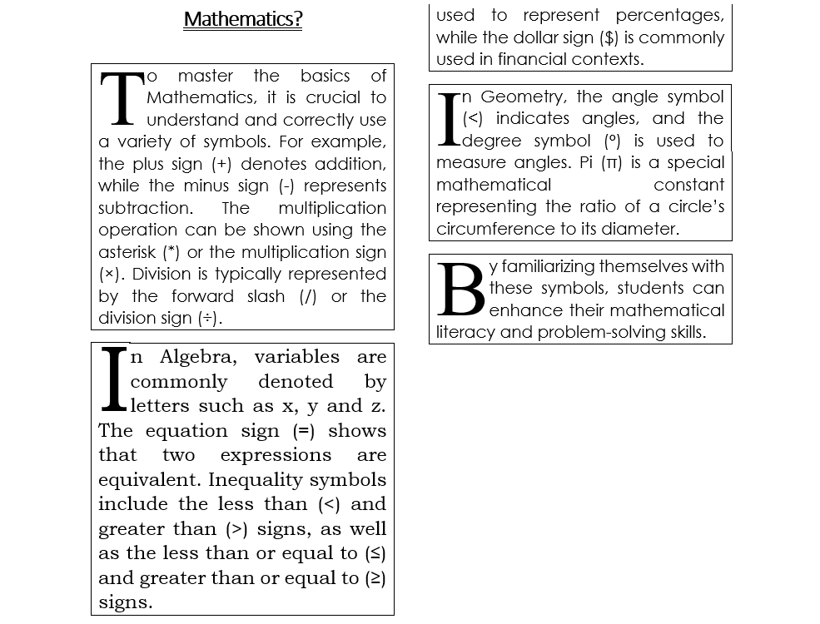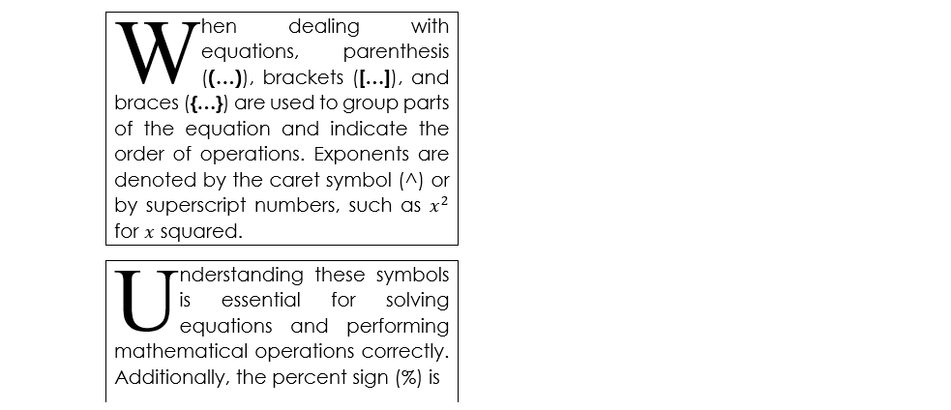

**2#** **Table: -**

1. In the total marks' column, entries should be calculated using formulas and it is the sum of marks in physics and marks in chemistry.  
   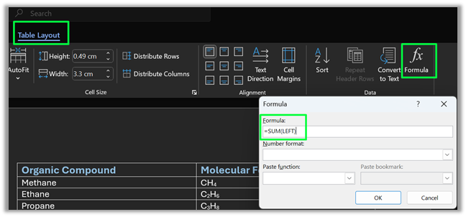
2. Insert a new row at the end of the table and also find grand total using formula.

Place cursor on last row à *Table Layout tab* à Insert below in the Rows & Columns subsectionà Go to Total Marks column cell in newest rowà Formula: =SUM(ABOVE) à Select last row’s cellsà Merge cells under Merge subsection

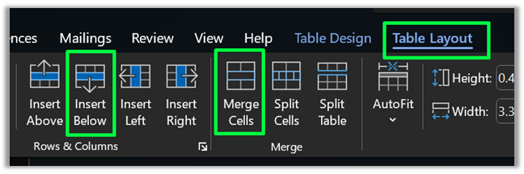

1. Sort the table based on total marks.

Step-1: Select Table

Step-2: *Table layout tab* à Sort

Step-3: Under sort by: Column 5, then select descending and Click OK.

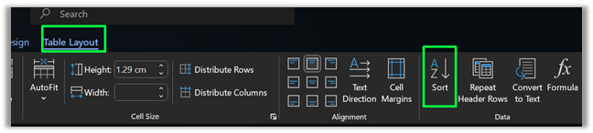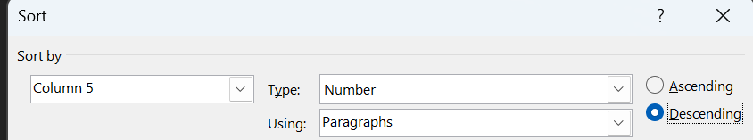

1. The date and heading should be centre aligned.

Step-1: Go to first row  
Step-2: *Table Layout tab.*   
Step-3: Insert Aboveà Repeatà Input Headingà Go to 2nd row  
Step-4: Go to *insert tab*à Under Text subsection, click Date & Timeà Select the first optionà Select first and second row one-by-one  
Step-5: Go to *Table Layout tab*à Under Merge subsection, click mergeà Select both rowsà Home Tabà Under paragraph subsection, click center aligned.

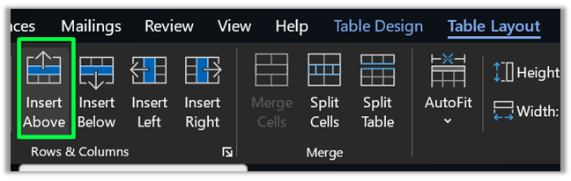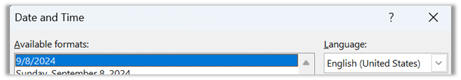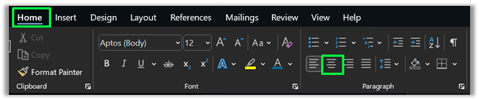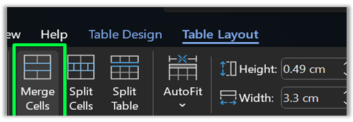

1. Heading should be in bold and underlined.

Step-1: Select Heading cell

Step-2: Go to Home tab

Step-3: Under Font, select Bold and Underline

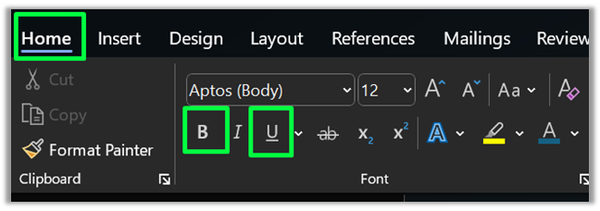

------------------------------------------------------------------------------------------------------

TABLE: -

|  |  |  |  |  |
| --- | --- | --- | --- | --- |
| **Student Marks** | | | | |
|  | | | | |
| **Roll No** | **Name** | **Marks in**  **Physics** | **Marks in**  **Chemistry** | **Total** **Marks** |
| **1** | Sakshi | 80 | 70 | 150 |
| **2** | Rohit | 70 | 80 | 150 |
| **3** | Amit | 60 | 50 | 110 |
| **4** | Rakesh | 40 | 60 | 100 |
| **5** | Komal | 30 | 70 | 100 |
| **6** | Garima | 80 | 80 | 160 |
| **Grand total: 770** | | | | |

**3#** Create a 5-slide presentation on any topic. Use Images, Graphs, Chart, Tables, Animation, Time, Bullets, Transition, Sound, Hyperlink, Background template, Header and Footer.

## **Slides:**

Step-1: Go to Insert Tab. Select “Text Box” from under “Texts” subsection and write “Computer Hardware”. Repeat for bottom box for student information.  
Step-2: Go to Home Tab, click on new slide --> Blank  
Step-3: Repeat x4  
Step-4: Go to last slide, Insert Tab, select “Text Box” from under “Texts” subsection and write “THANK YOU”.

## **Background template:**

1. Go to Design Tab.
2. Under Themes subsection, select any desired theme.

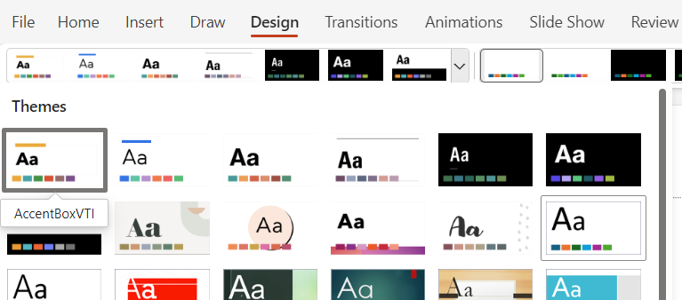

1. You may also use the Designer option for more customized themes that match your topic.



## **IMAGES:**

Step – 1: Go to Insert tab.

Step – 2: Click on the Pictures drop down button and proceed with the suitable choice.

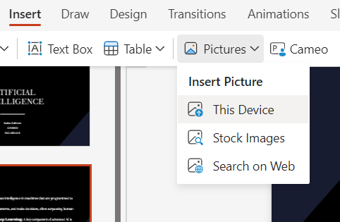

Step – 3: Select the image you want in your presentation and it will be displayed. Resize, crop or make other changes accordingly.

**CHART**

STEP – 1: Go to Insert Tab. In the Illustrations group, Click on Chart.

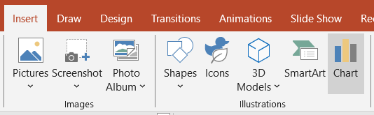

STEP – 2: Select suitable graph type. Here we are using the bar graph.

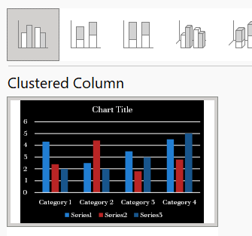

Now, a window like the one below will be displayed.  
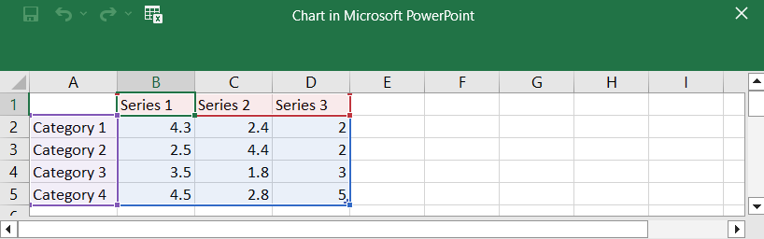Step – 3: Fill in the required data for your chart.

Step – 4: Your chart is ready.



**BULLETS**

Step – 1: Go to Home Tab.

Step – 2: In the Paragraph section, select Bullets. And from the Bullets and Numbering, choose any bullets for your text.

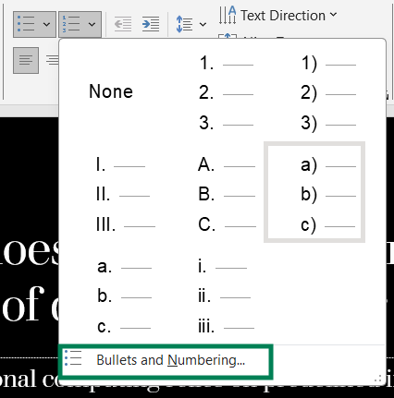 

**GRAPH**

STEP- 1: Go to Insert Tab. In the Illustrations section, click on Chart.

STEP- 2: Select Line graph. Enter data in the excel sheet displayed.

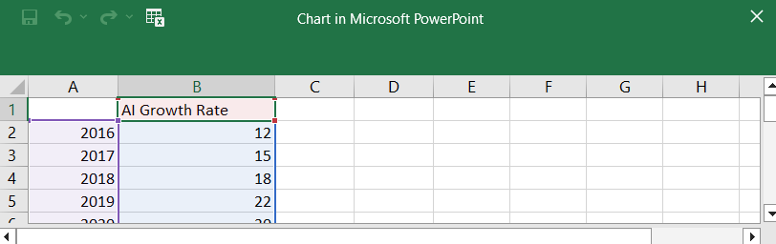

STEP- 3: Your Line graph is now complete.



**HYPERLINK**

Step – 1: Select the text, image or object you want to hyperlink.

### Step – 2: Open the Hyperlink Dialog

* **Right-click** the selected text or object.
* From the menu, click on **"Link"** or **"Hyperlink."**
  + Alternatively, you can press **Ctrl + K** on your keyboard.

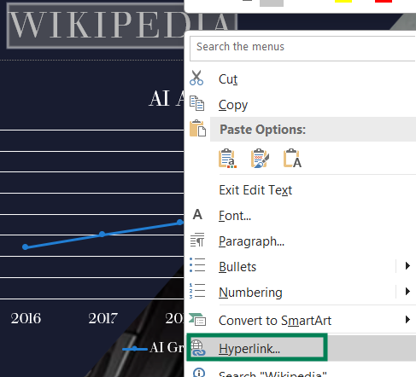

Step – 3: Insert the link

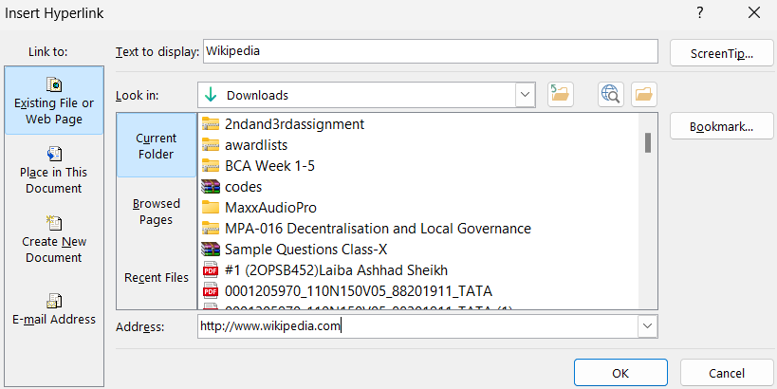  


**TRANSITION**

### STEP – 1: **Select the Slide:**

* Navigate to the slide where you want to add the transition.
* Click on the slide in the **Slide Pane** on the left side of the screen.

### STEP – 2: **Open the Transitions Tab:**

* Click on the **"Transitions"** tab located in the ribbon at the top of PowerPoint. Select a transition style. Here, it is Fade.

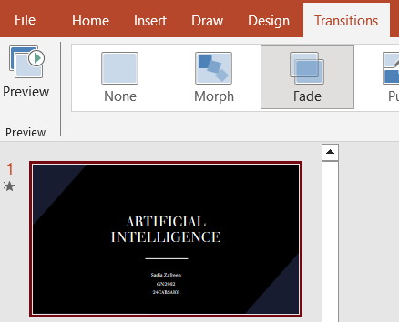

**TIME, HEADER & FOOTER**

Step – 1: Go to Insert Tab. Select ‘Date & Time’ in the *Text* section.

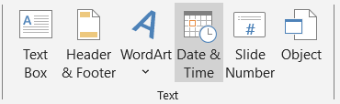

Step – 2: Do the necessary changes in the dialogue box that opens.

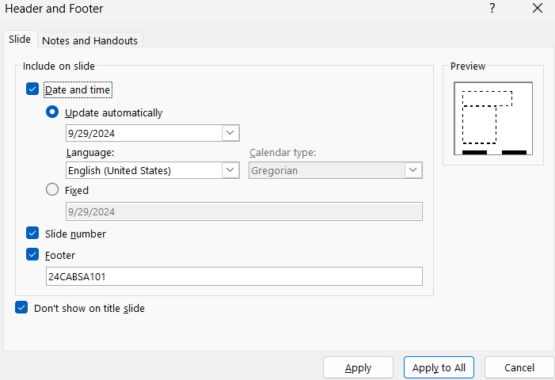

Step – 3: Click Apply to All.

**ANIMATION**

### **1. Select the Object to Animate:**

* Click on the **text box**, **image**, **shape**, or **object** on the slide that you want to animate.

### **2. Open the Animations Tab:**

### Click on the **"Animations"** tab in the ribbon at the top of PowerPoint.

**3. Choose an Animation Effect**

 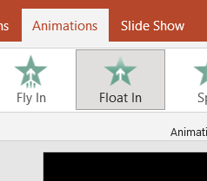

**SOUND**

### **1. Open PowerPoint and Select a Slide:**

* Go to the slide where you want to add the sound.

### **2. Insert the Sound:**

* Click on the **"Insert"** tab in the ribbon at the top.
* In the **Media** group, click on **"Audio."**
* You’ll see two options:
  + **Audio on My PC**: Select this to insert an audio file (e.g., MP3, WAV) from your computer.
  + **Record Audio**: Select this to record your own voice or sound directly into the presentation

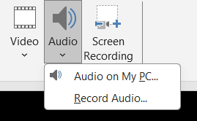

* Select the Audio you want and Click Insert.

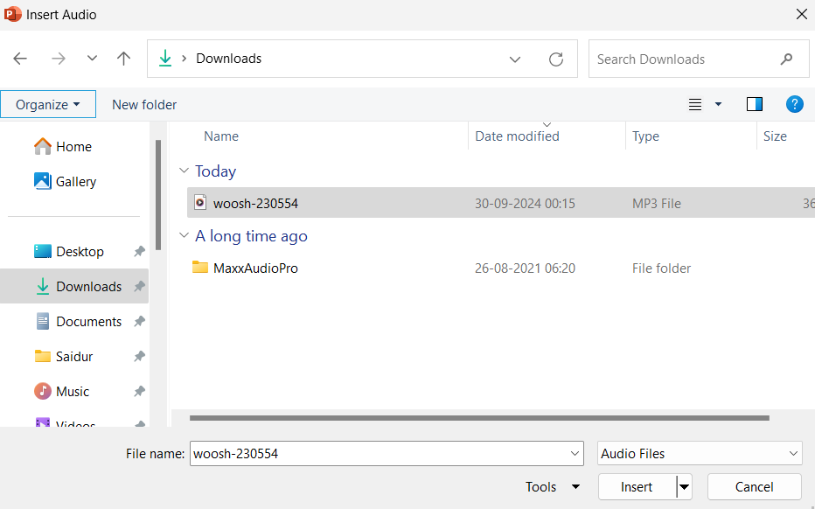

**TABLE**

1. Go to Insert Tab. Click on the Table drop down menu and select the no. of rows and columns you want.

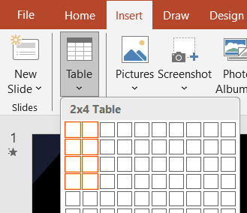

2. Edit the Table and make entries.

